Problem statement:

Perform the demographic analysis and create visualizations.

Calculate the distribution of marginal workers based on age, industrial category, and sex using data aggregation and manipulation.

Create visualizations using data visualization libraries (e.g., Matplotlib, Seaborn).

# to draw the graph of ratio between the rural and urban in each industries according to the district

def personsUrbanOrRural(df):

    cols = df.columns

    base = ["Area Name","Total/ Rural/ Urban","Age group"]

    persons = [item for item in cols if item.endswith("Persons")]

    persons = base + persons

    persons = df[persons]

    persons = persons[persons["Age group"] == "Total" ]

    persons = persons[persons["Area Name"] != "State - TAMIL NADU"]

    persons = persons[persons["Total/ Rural/ Urban"] != "Total"]

    persons= persons.drop("Age group",axis=1)

    persons = persons.reset_index()

    persons = persons.drop("index",axis=1)

    persons

    industry = persons.columns

    print(industry)

    for i in range(2,len(industry)):

        pivot_data = persons.pivot(index='Area Name', columns='Total/ Rural/ Urban', values=[industry[i]])

        ax = pivot_data.plot(kind="bar",stacked=True,title=industry[i])

        legand_label = ["Rural","Urban"]

        ax.legend(labels=legand_label,loc='lower center', bbox_to_anchor=(0.5, 1.15))

        plt.show()

personsUrbanOrRural(df)

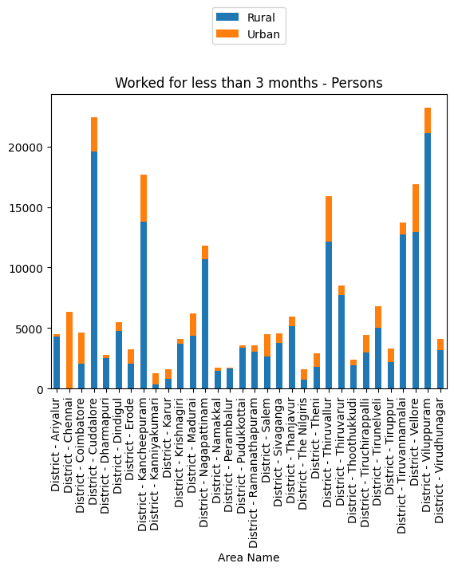

#To find the total workers no of person worked in each district

def personsTotal(df):

    cols = df.columns

    base = ["Area Name","Total/ Rural/ Urban","Age group"]

    persons = [item for item in cols if item.endswith("Persons")]

    persons = base + persons

    persons = df[persons]

    persons = persons[persons["Age group"] == "Total" ]

    persons = persons[persons["Total/ Rural/ Urban"] == "Total"]

    persons= persons.drop("Age group",axis=1)

    persons = persons.drop("Total/ Rural/ Urban",axis=1)

    persons = persons.drop(0)

    persons = persons.reset_index()

    persons = persons.drop("index",axis=1)

    title=persons.columns

    for i in  range(1,len(title)):

        persons.plot(x="Area Name", y=title[i], kind='bar',legend=False)

        plt.ylabel(title[i])

        plt.show()

personsTotal(df)

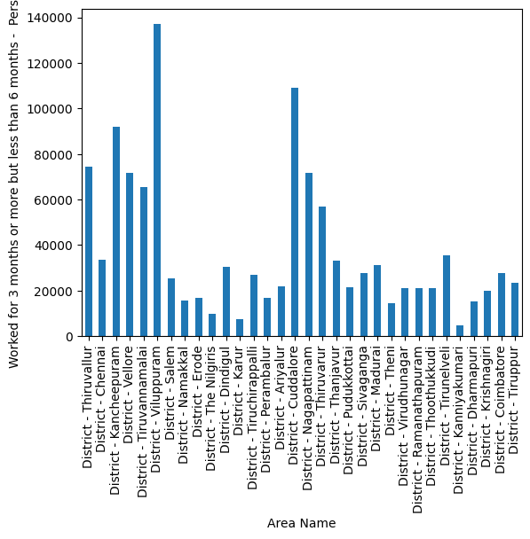

#to analysis the age group by industrydata ,district,category

def AnalysisByIndustry(industryData,district,category):

    district = industryData[industryData["Area Name"]==district]

    district = district.drop("Area Name", axis=1)

    district = district[district["Total/ Rural/ Urban"]==category]

    district = district.drop("Total/ Rural/ Urban",axis=1)

    district = district.drop(district.index[0])

    district.plot(x="Age group",kind="bar",stacked=True)

    plt.show()

AnalysisByIndustry(industriesName[1],"District - Tiruppur","Total")

